**Assignment No. 4**

**Group ID:** 2018BCGRP10

**Batch:** T2

**PRN No:** 2018BTECS00072 & 2018BTECS00086

* **Title: Online MCQ Exam Portal**
* **Aim:** Design and implement a system for managing online multiple-choice tests. The system should support distributed contribution of questions by teaching assistants, editing of the questions by whoever is in-charge of the course and creation of tests from the available set of questions. It should be able to administer the tests online, either at a fixed time for all students or at any time but with a time limit from start to finish and give students feedback on their scores at the end of the exam.
* **Introduction:**

**C#.Net:**

C# (C-Sharp) is a programming language developed by Microsoft that runs on the .NET Framework. C# is used to develop web apps, desktop apps, mobile apps, games and much more.

The C#.NET is one of the Microsoft programming languages. It is the most powerful programming language among all programming languages available in the .NET Framework. The C#.NET contains all the features of C++, VB.NET, JAVA, and also some additional features.

The C#.Net programming language is designed to be a simple, modern, general-purpose, and completely object-oriented programming language.

**MySQL:**

MySQL is an open-source relational database management system (RDBMS). A relational database organizes data into one or more data tables in which data types may be related to each other; these relations help structure the data. SQL is a language programmers use to create, modify and extract data from the relational database, as well as control user access to the database.

In addition to relational databases and SQL, an RDBMS like MySQL works with an operating system to implement a relational database in a computer's storage system, manages users, allows for network access and facilitates testing database integrity and creation of backups.

**Bootstrap:**

Bootstrap is a free and open-source CSS framework directed at responsive, mobile-first front-end web development. It contains CSS- and (optionally) JavaScript-based design templates for typography, forms, buttons, navigation, and other interface components.

* **Functional Block Diagram:**

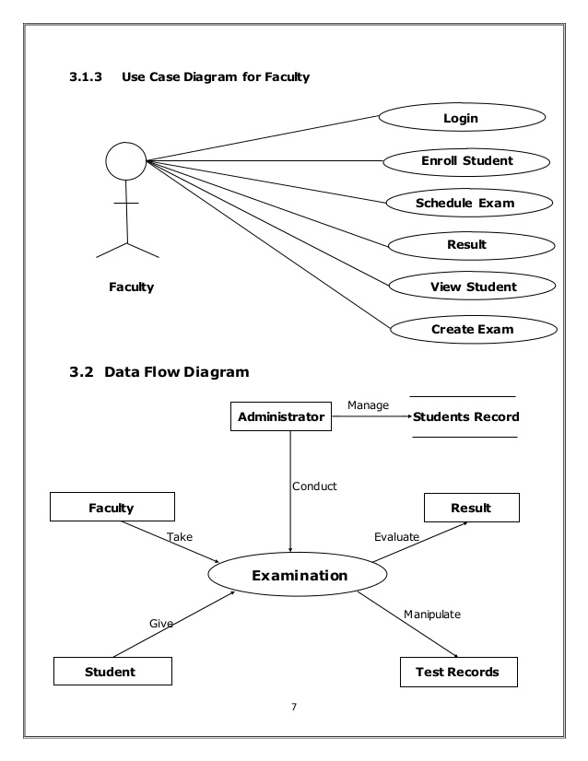



* **Screenshots of experiment:**

1. Connection has been established with username as our group id- 2018BCGRP10

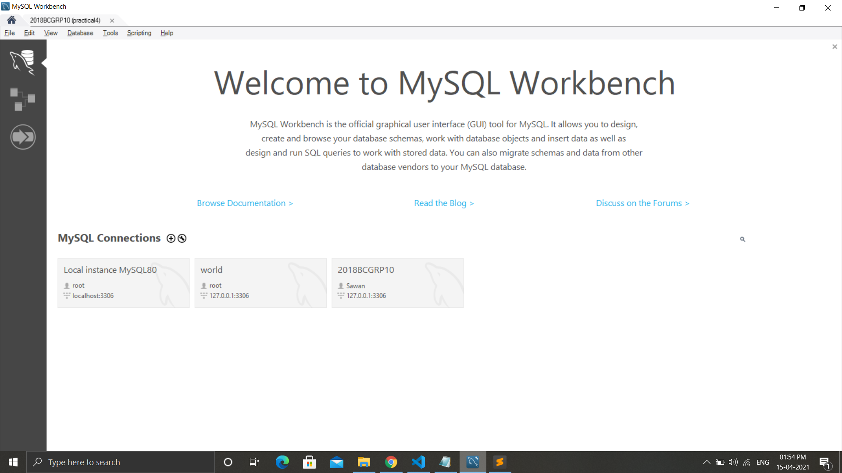

1. Home page

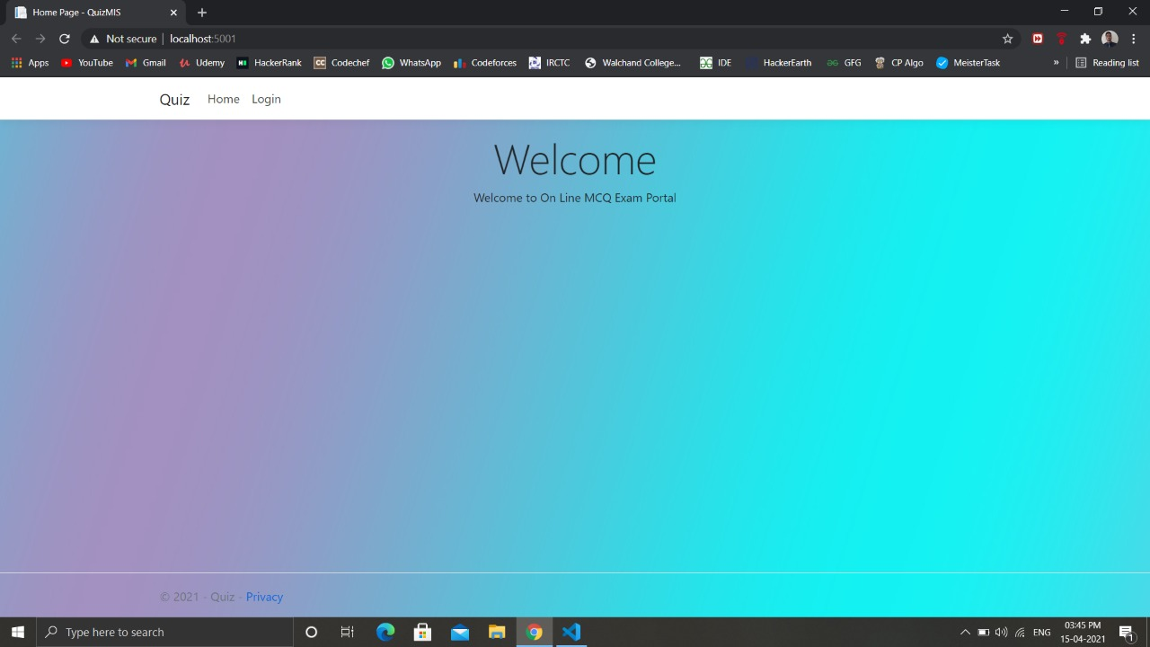

1. Login page

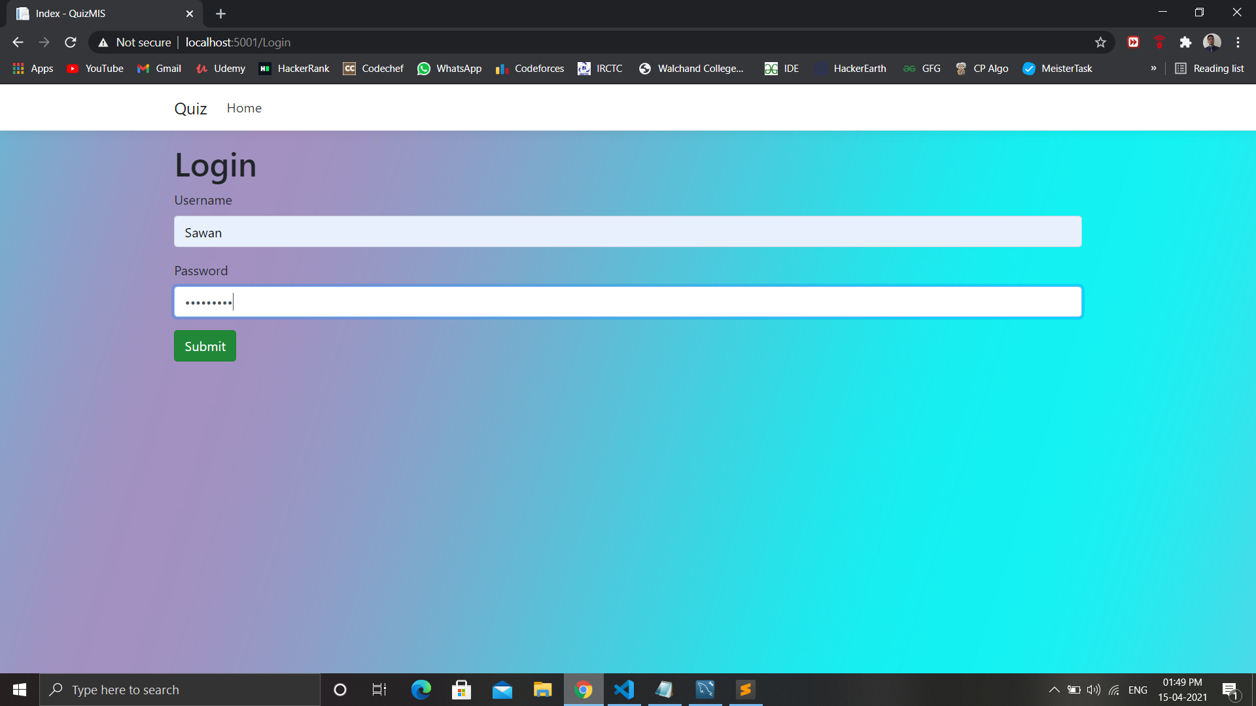

1. After login, quiz details have been displayed

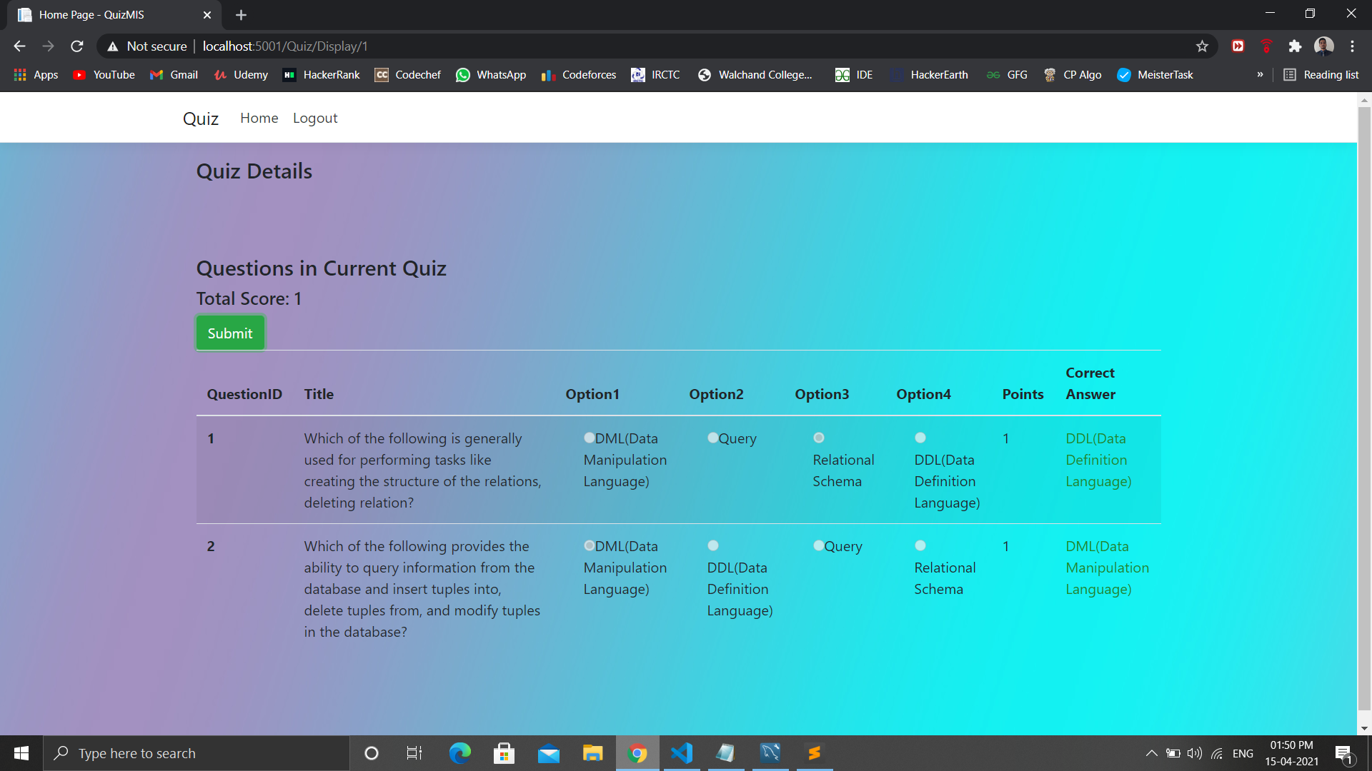

1. Student dashboard-1

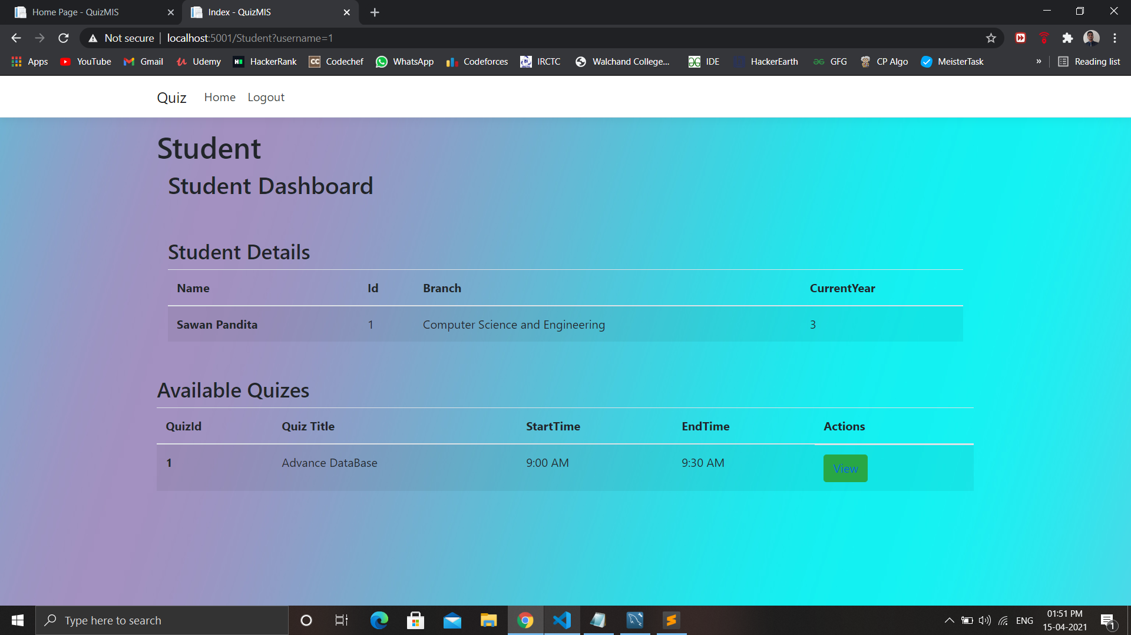

1. Student dashboard-2

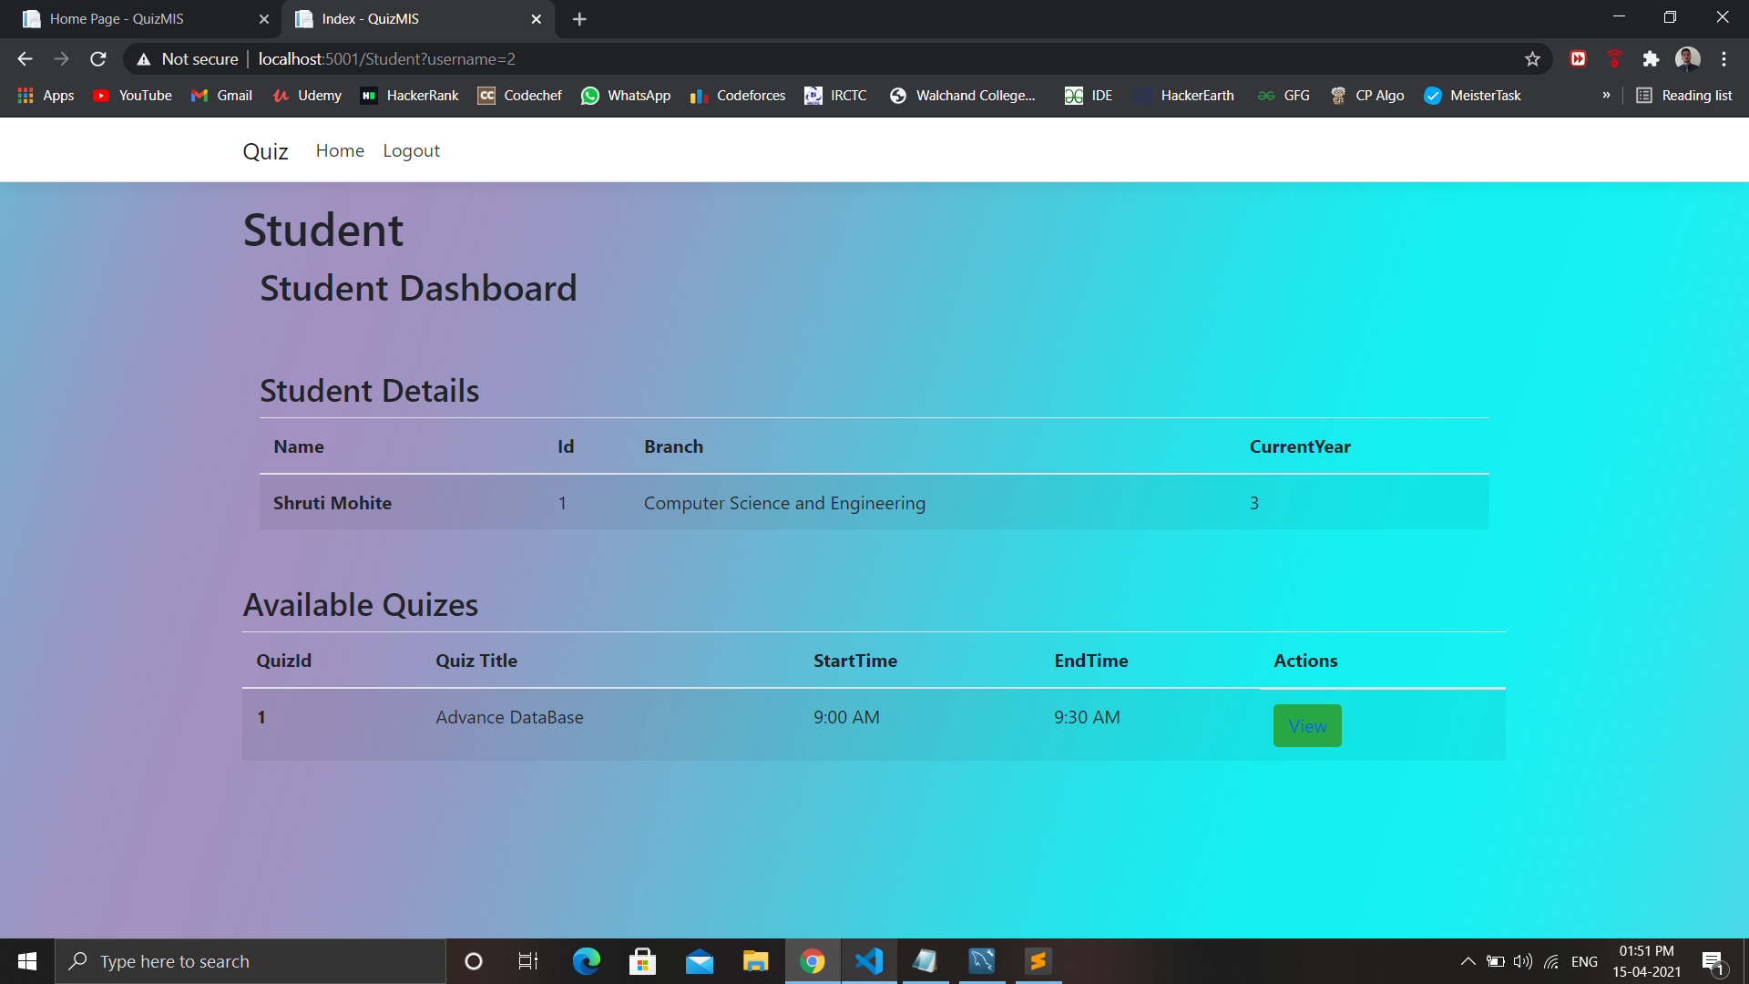

1. Teacher dashboard

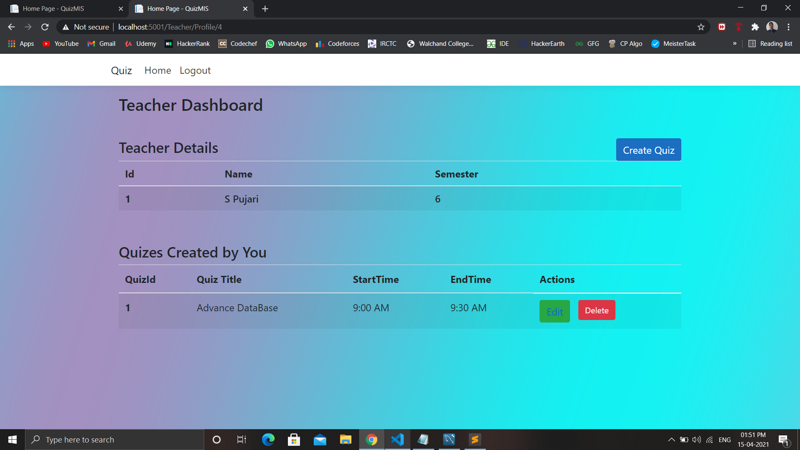

1. Create Quiz section

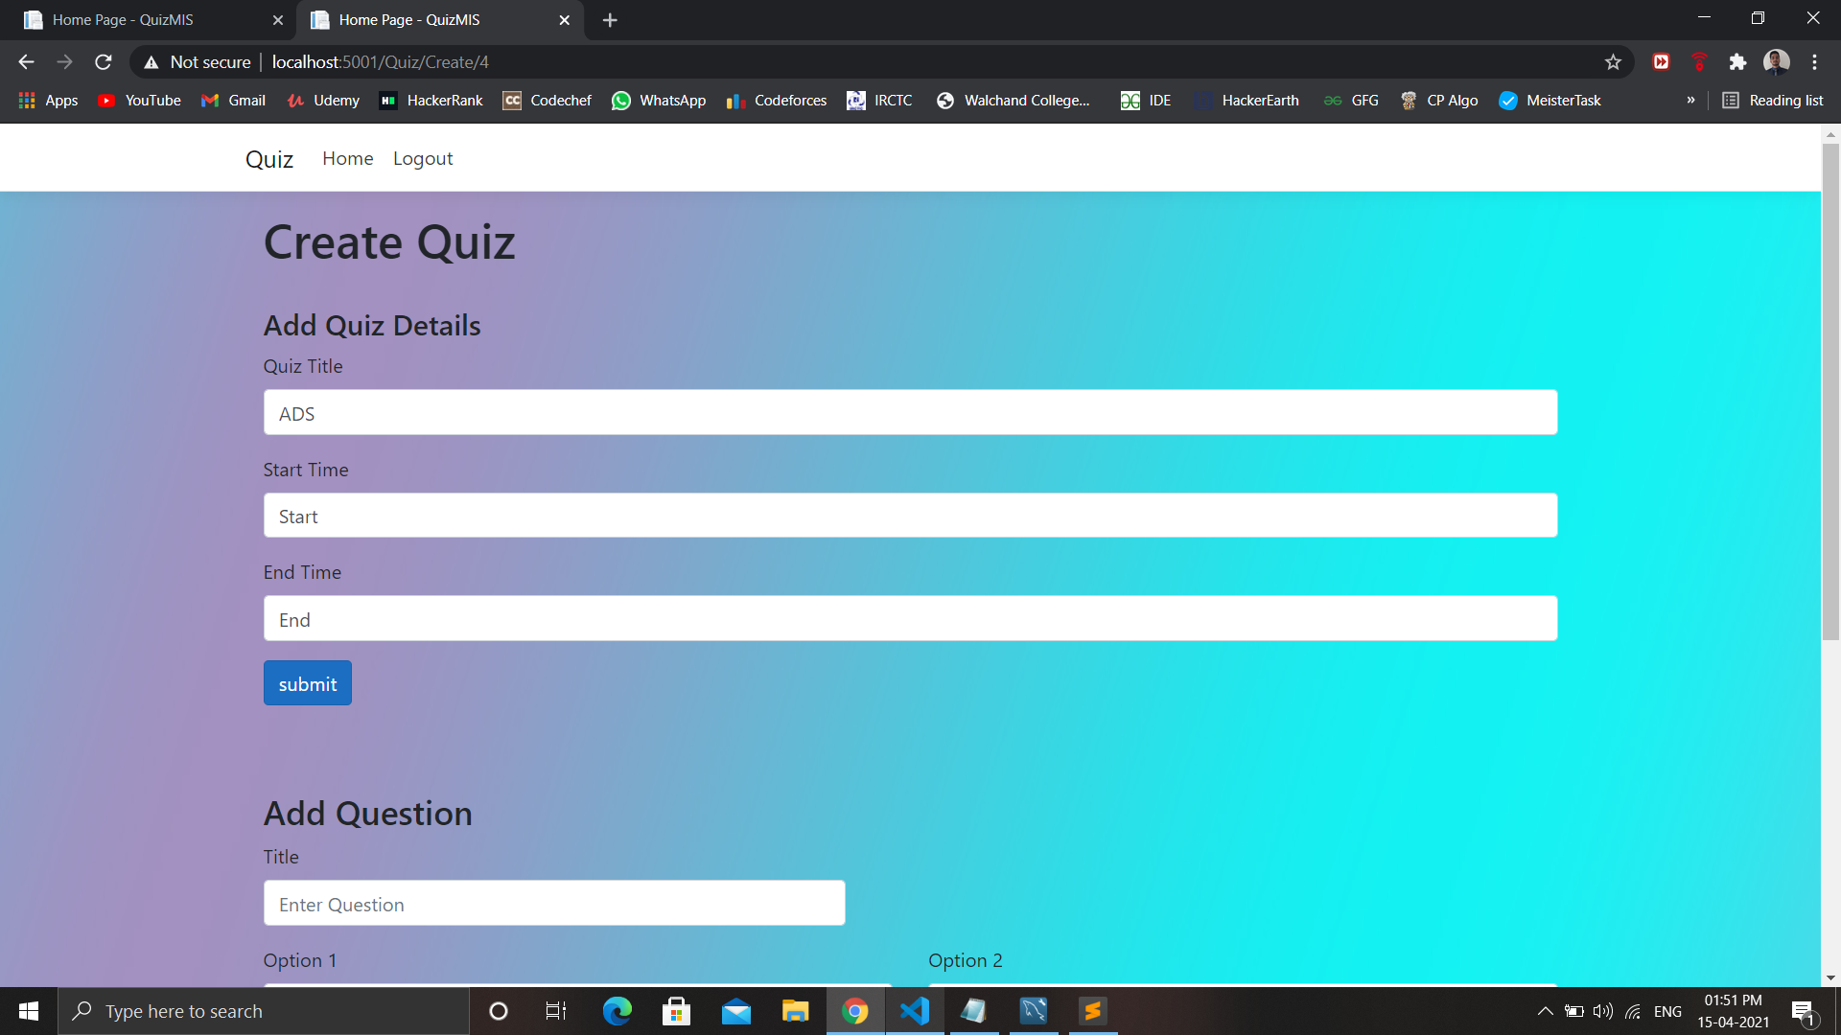

1. Add Question section

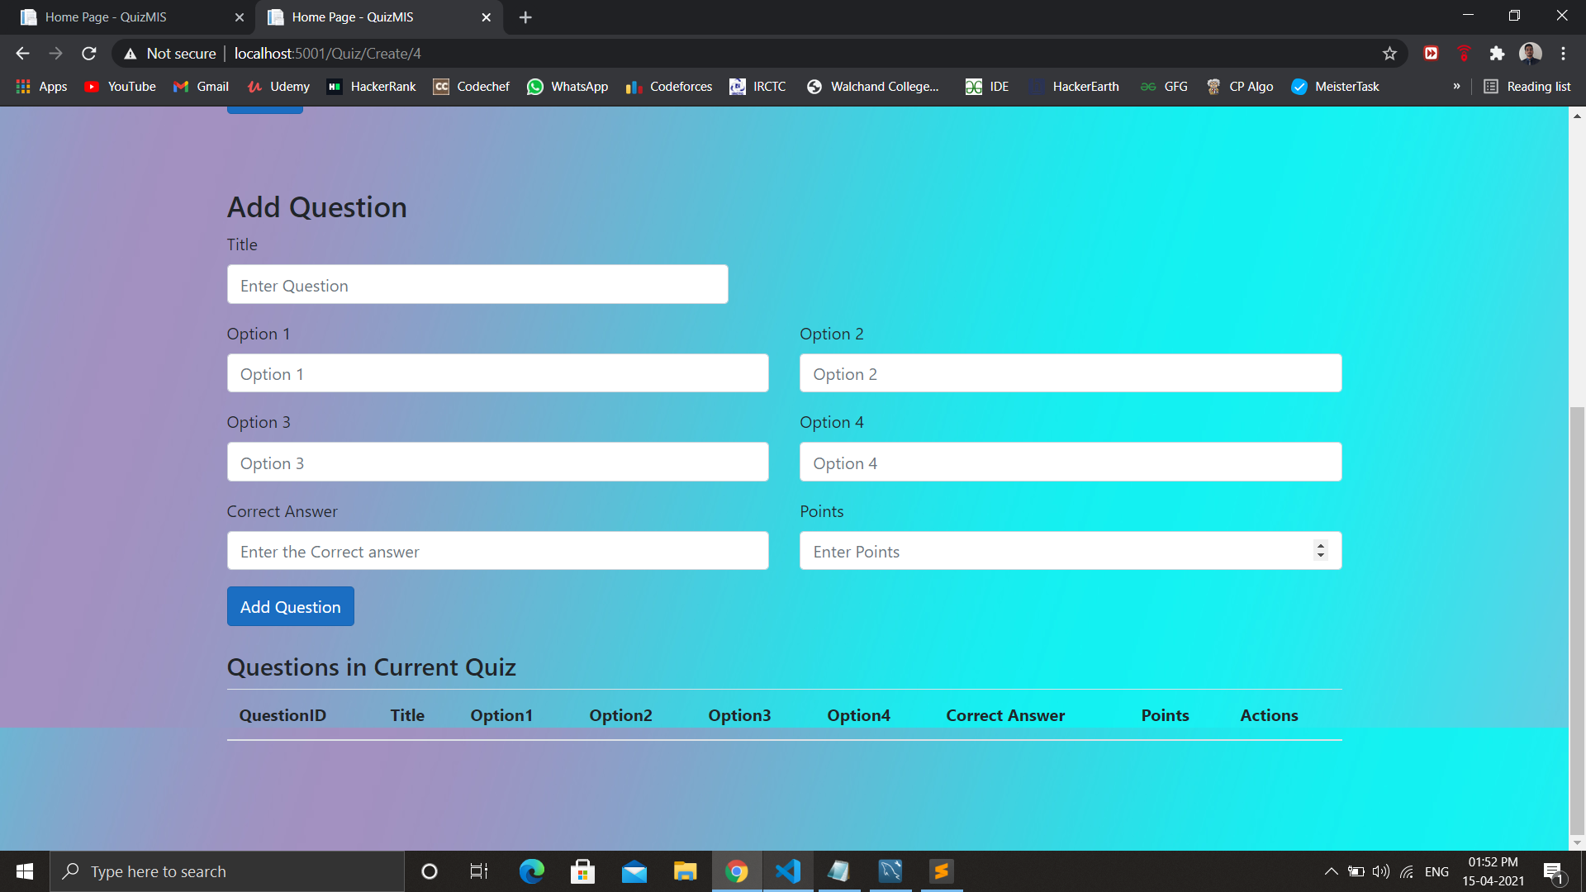

1. Question in Current Quiz section

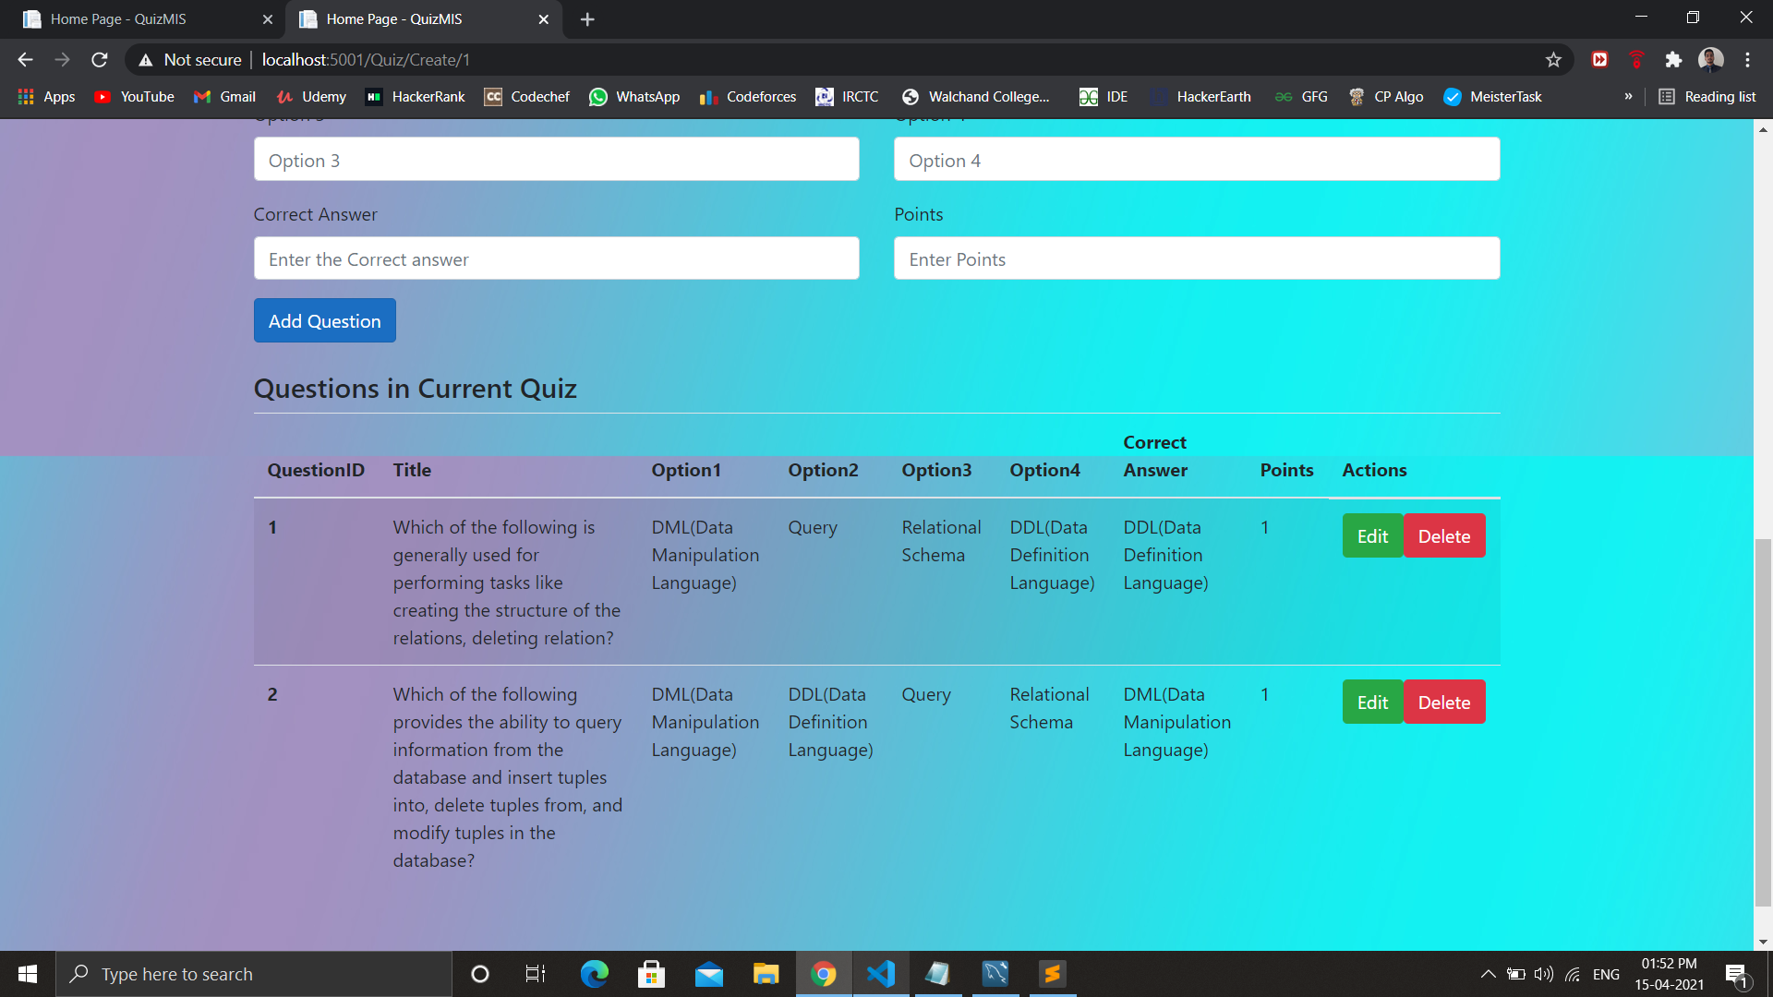

1. Update Question section

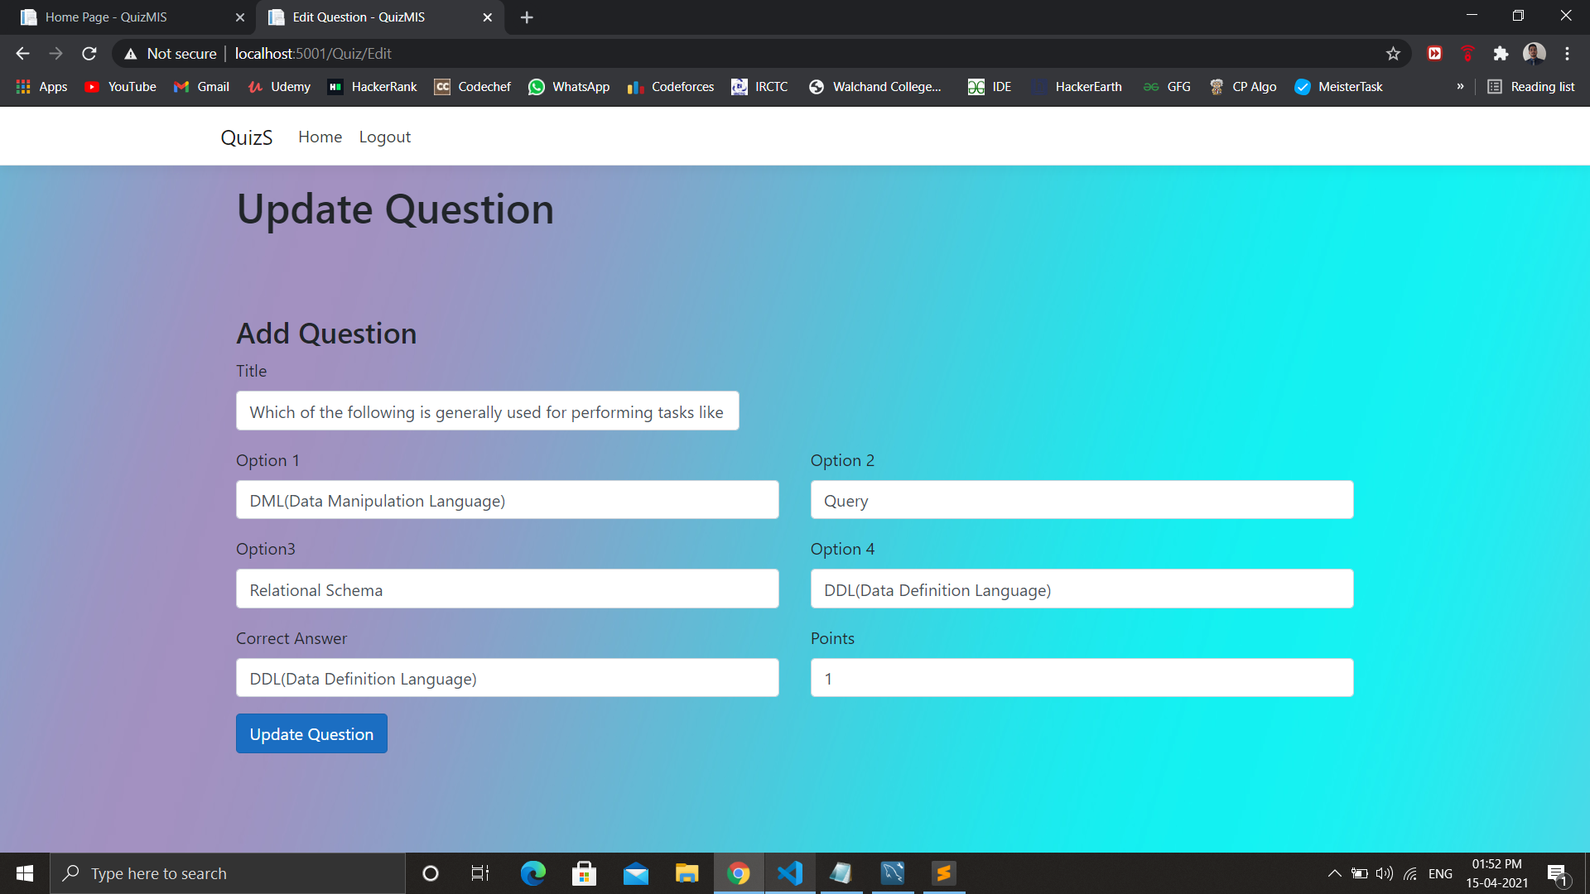

* **Conclusion:**

1. User management at different levels like teacher and student has been implemented by this system.
2. This system will surely help teachers to conduct quizzes without any interruption and also it is user friendly for both students and teachers.

* **References:**

1. <https://blog.mettl.com/guide/online-examination/>
2. <https://blog.cengage.com/tips-taking-online-exams/>
3. <https://www.mysql.com/>
4. <https://www.w3schools.com/cs/>
5. <https://getbootstrap.com/>